**Mete Uz**

**Project**

**Introduction**

In this project I compared the performance of 4 different network architectures on classification of a medical image dataset. The dataset I used is the same one used in homeworks where we classified colon tissue which has 144 images in the test set and 144 images in the training set. The networks I used are NASnet-Mobile, Resnet-152, MobileNet and MobileNetv2. In the code I used the keras library and in evaluation I found that the MobileNetv2 performs best.

**Network Architecture**

**NASnet-mobile:** It is essentially a network that searches for the best algorithm that would give the best performance on the given set. It can evaluate the performance of the architecture it constructed without training it and can create a better architecture depending on its performance. It uses methods such as reinforcement learning and evolutionary algorithms to achieve this. I used the mobile version for performance and test the ability of NAS on medical images.

**Resnet-152:** Resnet is a 152 layer network that solves the problem of vanishing/exploding gradients present in deep networks via skip connections. By this the input is not degraded if such a problem occurs in one of the layers because the original input is kept. I used this network to its performance is as good on medical images as U-Net which also uses skip connections.

**MobileNet:** Mobilenet is a fast network with relatively basic architecture with 28 layers. It uses depthwise separable convolution layers which perform two separate convolution operations on the image which decreases the computational cost greatly. It also uses resolution and width multipliers that can be adjusted to trade accuracy for speed. I used this network see its performance on medical images because of the real-time applications of different imaging modalities.

**MobileNetV2:** MobileNetv2 is improves upon mobilenet with skip connections like the ResNet architecture. I used this to compare the performance of both versions on medical images.

In all networks I tried different methods such as changing the activation functions however I saw that the vanilla architectures gave the best result therefore I used them.

**Code**

I used the Keras library in my code. I defined a step decay function which decreased the learning rate as the training went on. I augmented the training images by randomly adding noise, changing hue, contrast, brightness, rotation and other different operations. I also used transfer learning by using models pretrained via imagenet. I used cross-entropy as loss function and used softmax activation for classification. I saved the models used as h5 format and the output data in pb format. I also saved the misclassified images separately to see if which classes are likely to be misclassified and if they were different for each model.

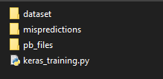

**Figure 1:** Directory structure

directory2

**Figure 2:** Dataset directory

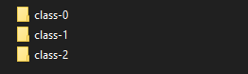

**Figure 3:** Directory names for class folders

**Results**

|  |  |  |  |  |
| --- | --- | --- | --- | --- |
|  | **NASnet-mobile** | **ResNet-152** | **MobileNet** | **MobileNetv2** |
| **Misprections** | 14 | 3 | 3 | 3 |
| **Test accuracy** | 0.781 | 0.953 | 0.953 | 0.953 |
| **Training accuracy** | 0.816 | 0.968 | 0.996 | 0.981 |
| **Validation accuracy** | 0.75 | 0.97 | 0.96 | 0.94 |
| **Speed (Time to process 64 images) (sec)** | 0.0154 | 0.0589 | 0.0115 | 0.0165 |

**Figure 4:** Comparison of speed and accuracy of different models

**Notes on Misclassifications:** All misclassifications NASnet belonged to class 2 while the more accurate models classifed 3, 2 for mobilenetv2 as the other image belonged to class 2, class 1 images as class 2. Image 62 was falsely classified by ResNet-152 and MobileNetv2 while image 70 was falsely classified by all three models.

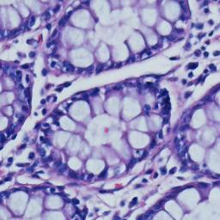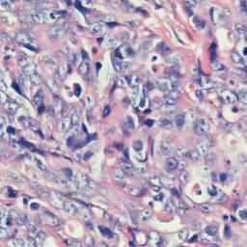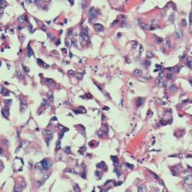

**Figure 5:** Sample colon tissue images from each class in order 0,1,2. Notice how class 1 and 2 look similar and therefore prone to misclassification. Middle image is image 70 which was falsely classified by three of the most accurate networks.

**Discussion**

Overall the accuracy of ResNet, MobileNet and Mobilenetv2 outperformed NASnet-mobile. While the three models provided satisfactory results, the Mobilenet architecture is preferable as it is also the fastest. Interestingly MobileNet outperformed MobileNetv2 as the second version was released as an upgrade in both speed and accuracy. The models also expectedly struggled between class 1 and 2 as they look similar and there were no misclassifications to class 0. This was not the case with NASNet however which indicates that the network might not be suitable for this application or might need more training.